Name: Sirisha Gumpina

Email: siri.gumpina@gmail.com

Assignment-1

Connect and disconnect with login Access

* What happens when you login a non-existent users or username?
  + Provide Screenshot and What you understand, explain in short brief?

Doesn’t allow non-existent users to login. Throws an error message

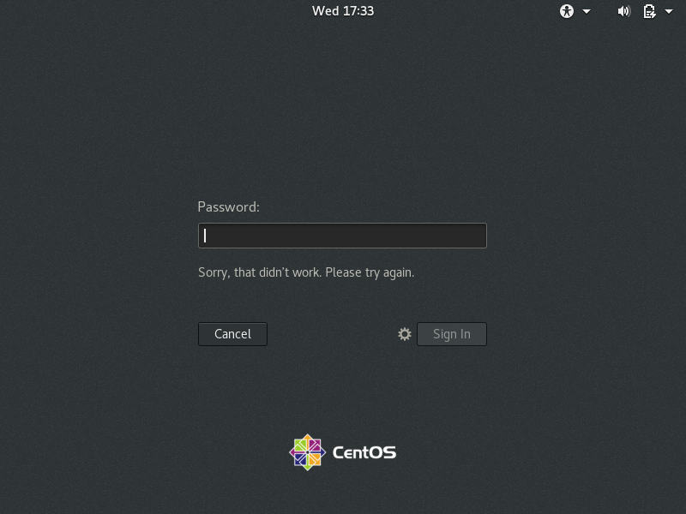

Assignment-2

Password changing

* Login into your account and then change password?
  + Change your password into ***IneuR0n#42*** and hit the **Enter** key
    - Explain what happen and give screenshot?

Password changed successfully as it is a complex password

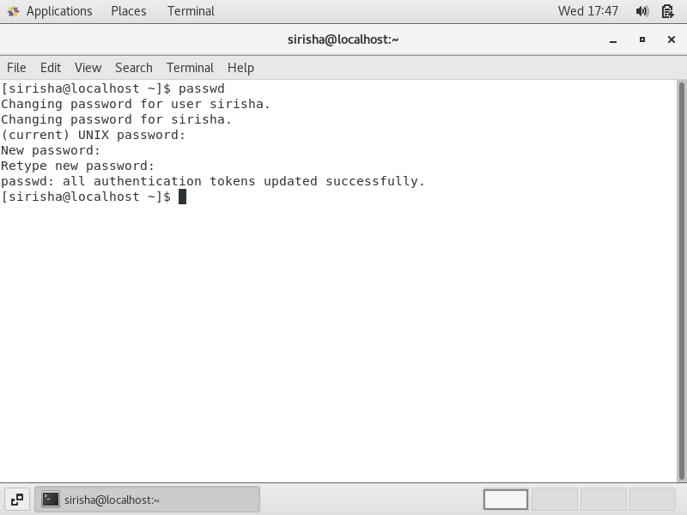

* + Try again to change password but use like password ***1234*** or ***abcd***
    - Explain what happen and give screenshot?

Password is not changed as it is less than 8 characters. When we give a simple password of 8 characters, still it is not changed as it is too simple/systematic

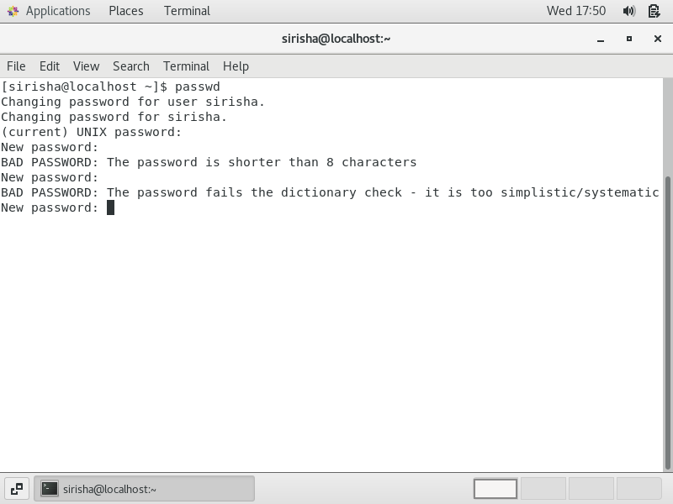

* + Try again to change password but now don’t use any password just hit **Enter** key
    - Explain what happen and give screenshot?

Throws password that no password is supplied

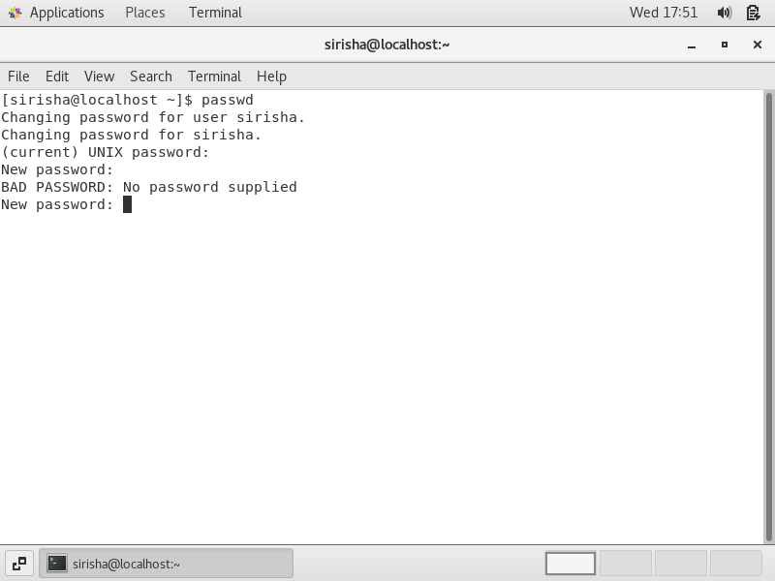

Assignment-3

Working with Directories

* Enter the command **cd /** and then **ls** and then hit **Enter** key
  + Take screenshot and explain what output we got?

This command is used to change directory to /, which is the root directory in linux systems. It is the first directory in filesystem hierarchy (similar to C:/ drive in Windows system)

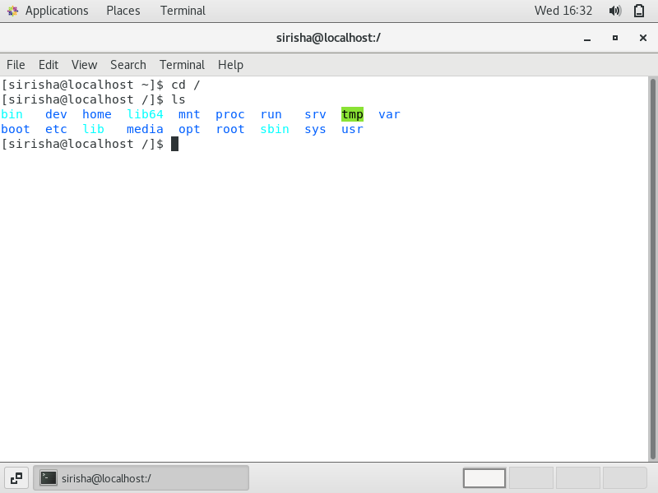

* Enter the command now **cd /home** and then hit **Enter** key
  + Do **ls,** provide screenshot and explain what is **/home** directory used for?

This command is used to change directory to the home directory. It is like a sub-directory for the root directory. It is like a personal working space for the logged in user.

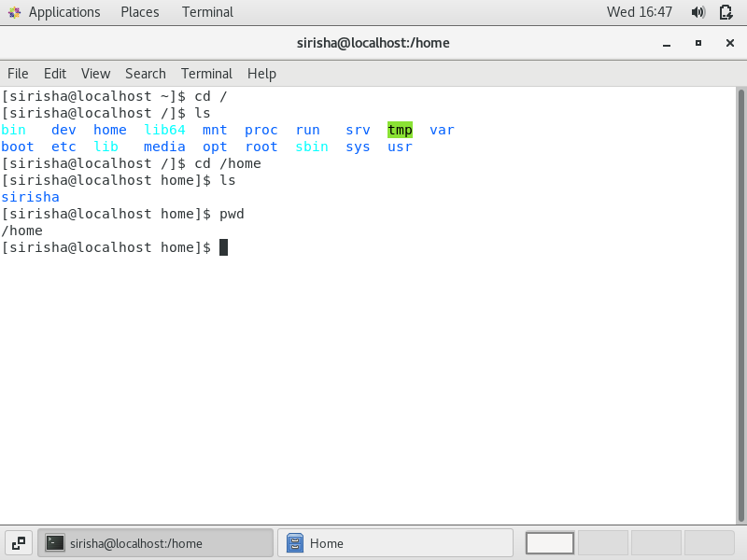

* Enter **cd ..** and hit **Enter** key [ *Note: here we have space after cd then use double dot*]
  + Check what happen and give screenshot?

This command is used to change directory to the root directory (i.e /)

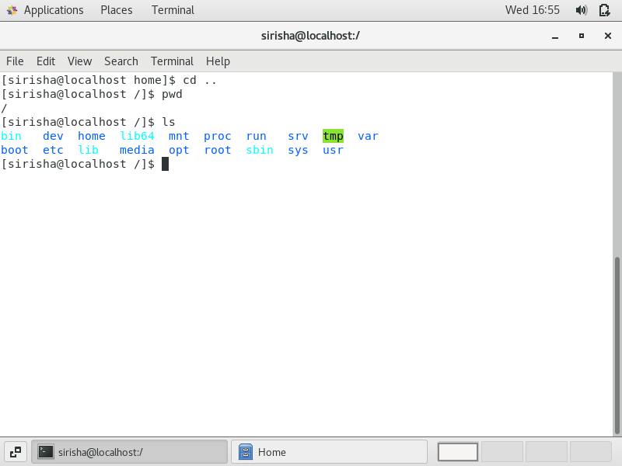

* Now enter **cd /var/www/html** and then type **cd** and hit **Enter** key
  + Explain what happen and give screenshot?

This command is used to html directory which is in var/www. However I am getting error as I don't have www directory under /var directory

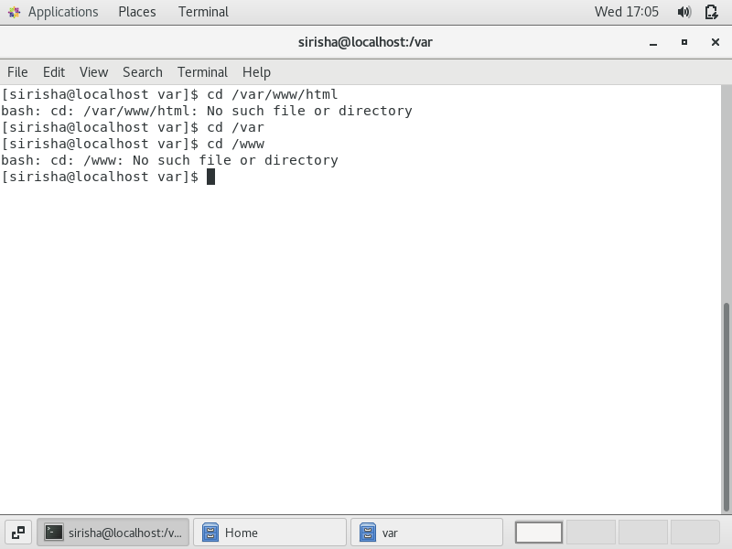

* Now type **cd /root** and then hit **Enter** key
  + Do **ls,** check any output we have on screen if yes then take screenshot?

Got error as normal user. But as root user, this is used to change directory to the root user directory

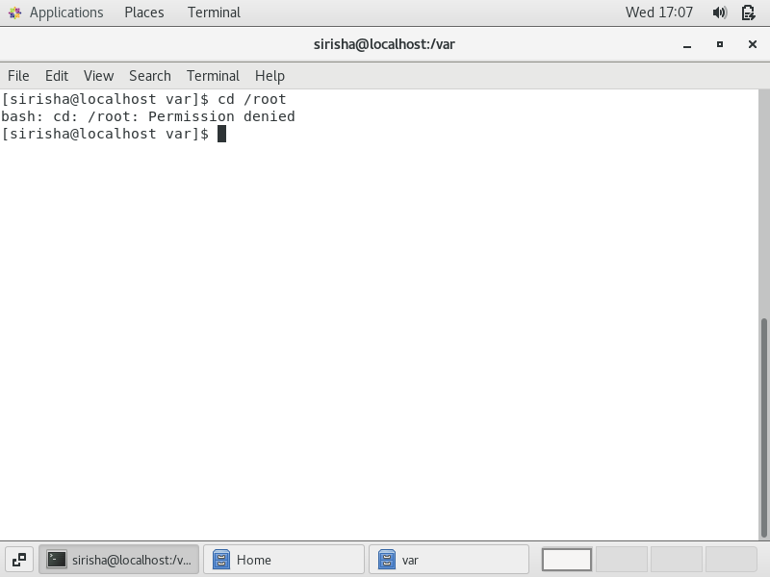

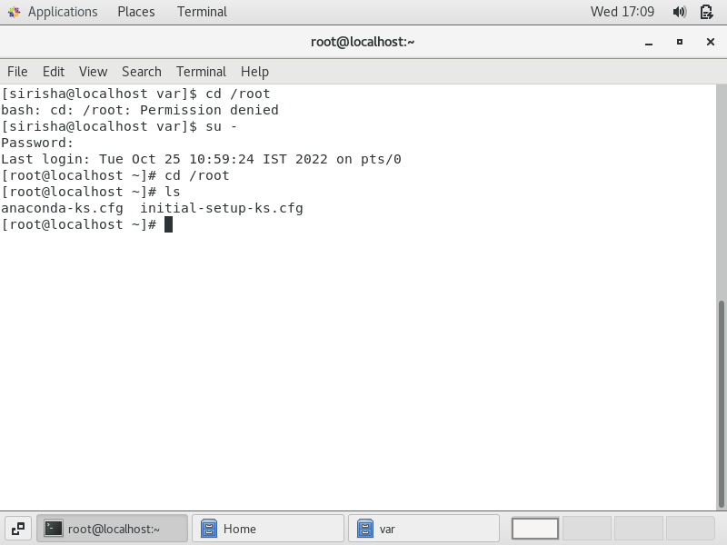

Assignment-4

Working with File Listing

* Go to **cd /etc** and type **ls**
  + Take screenshot and explain what files you have seeing?
  + Take screenshot and explain what different output you found compare to previous command you used?

This command is used to change directory to the/etc directory in the root directory. It Contains system-wide configuration files and system databases

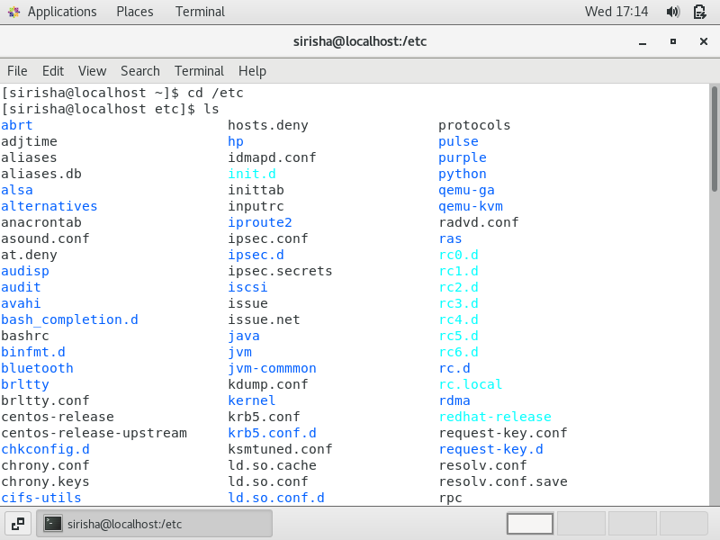

* Then type **ls -al** and hit **Enter** key
  + Take screenshot and explain what new file or directory you found?

Found files related to bluetooth,cron expressions, fonts, yum etc

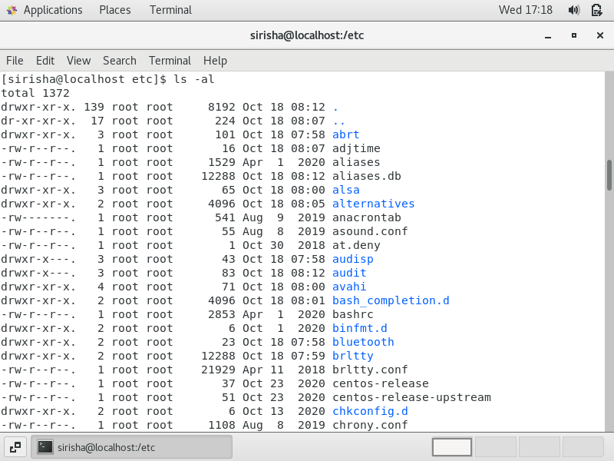

* Then use **ls -i** and hit **Enter** key
  + Now see what different output its shows and take screenshot?

Index number of each file is displayed

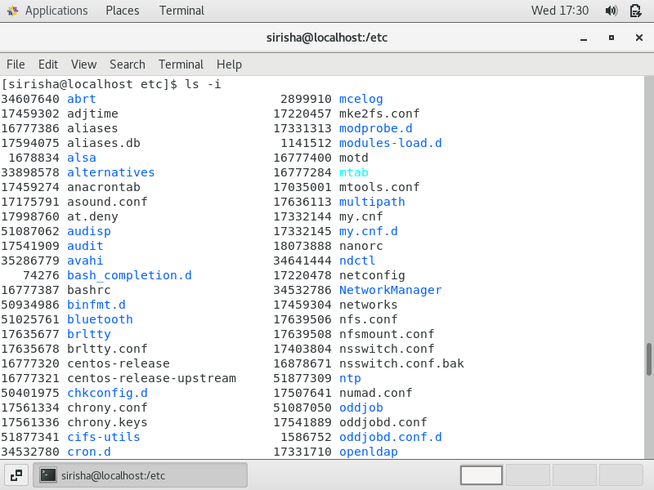

* Then use **ls –help** and see other options about **ls** command
  + Explore it and try with other attribute we can use with **ls** command

Assignment-5

Know where you are and where you working

*Here we use* ***pwd, cd and ls*** *as combine task to understand where you working on terminal and how you can switch from one directory to another one.*

* Open terminal after restart the linux
  + Check which location you working, type **pwd** and take screenshot

Working in the user directory (current logged in user) in the home directory

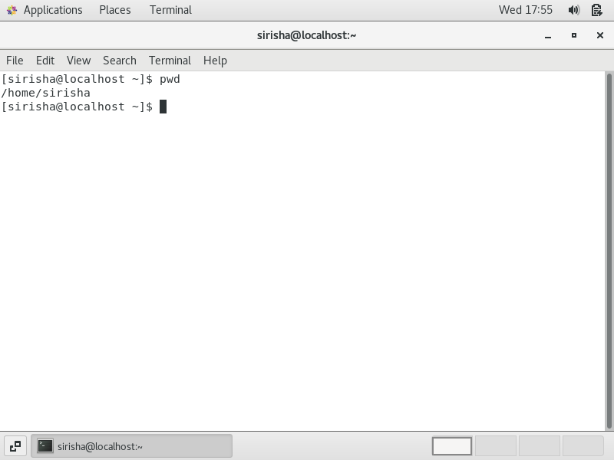

* Now use **cd /var** and hit **Enter** key
  + Do **ls,** and see what output comes, give screenshot?

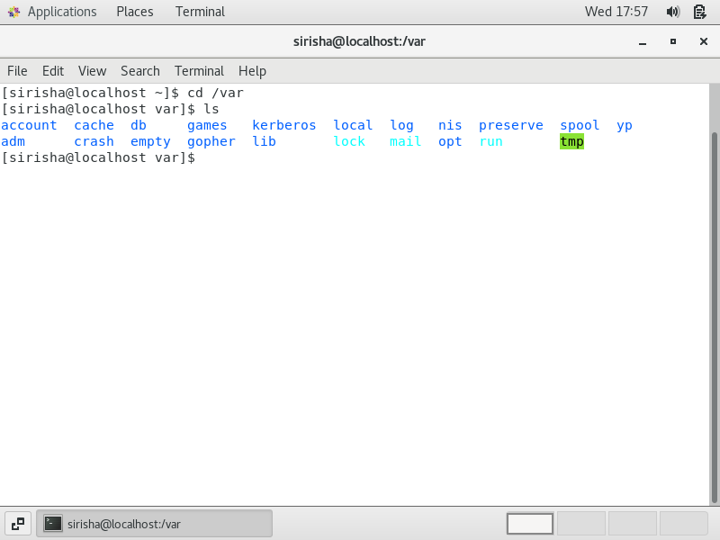

* Do explore other help options of each command to learn more other things we can do with these commands